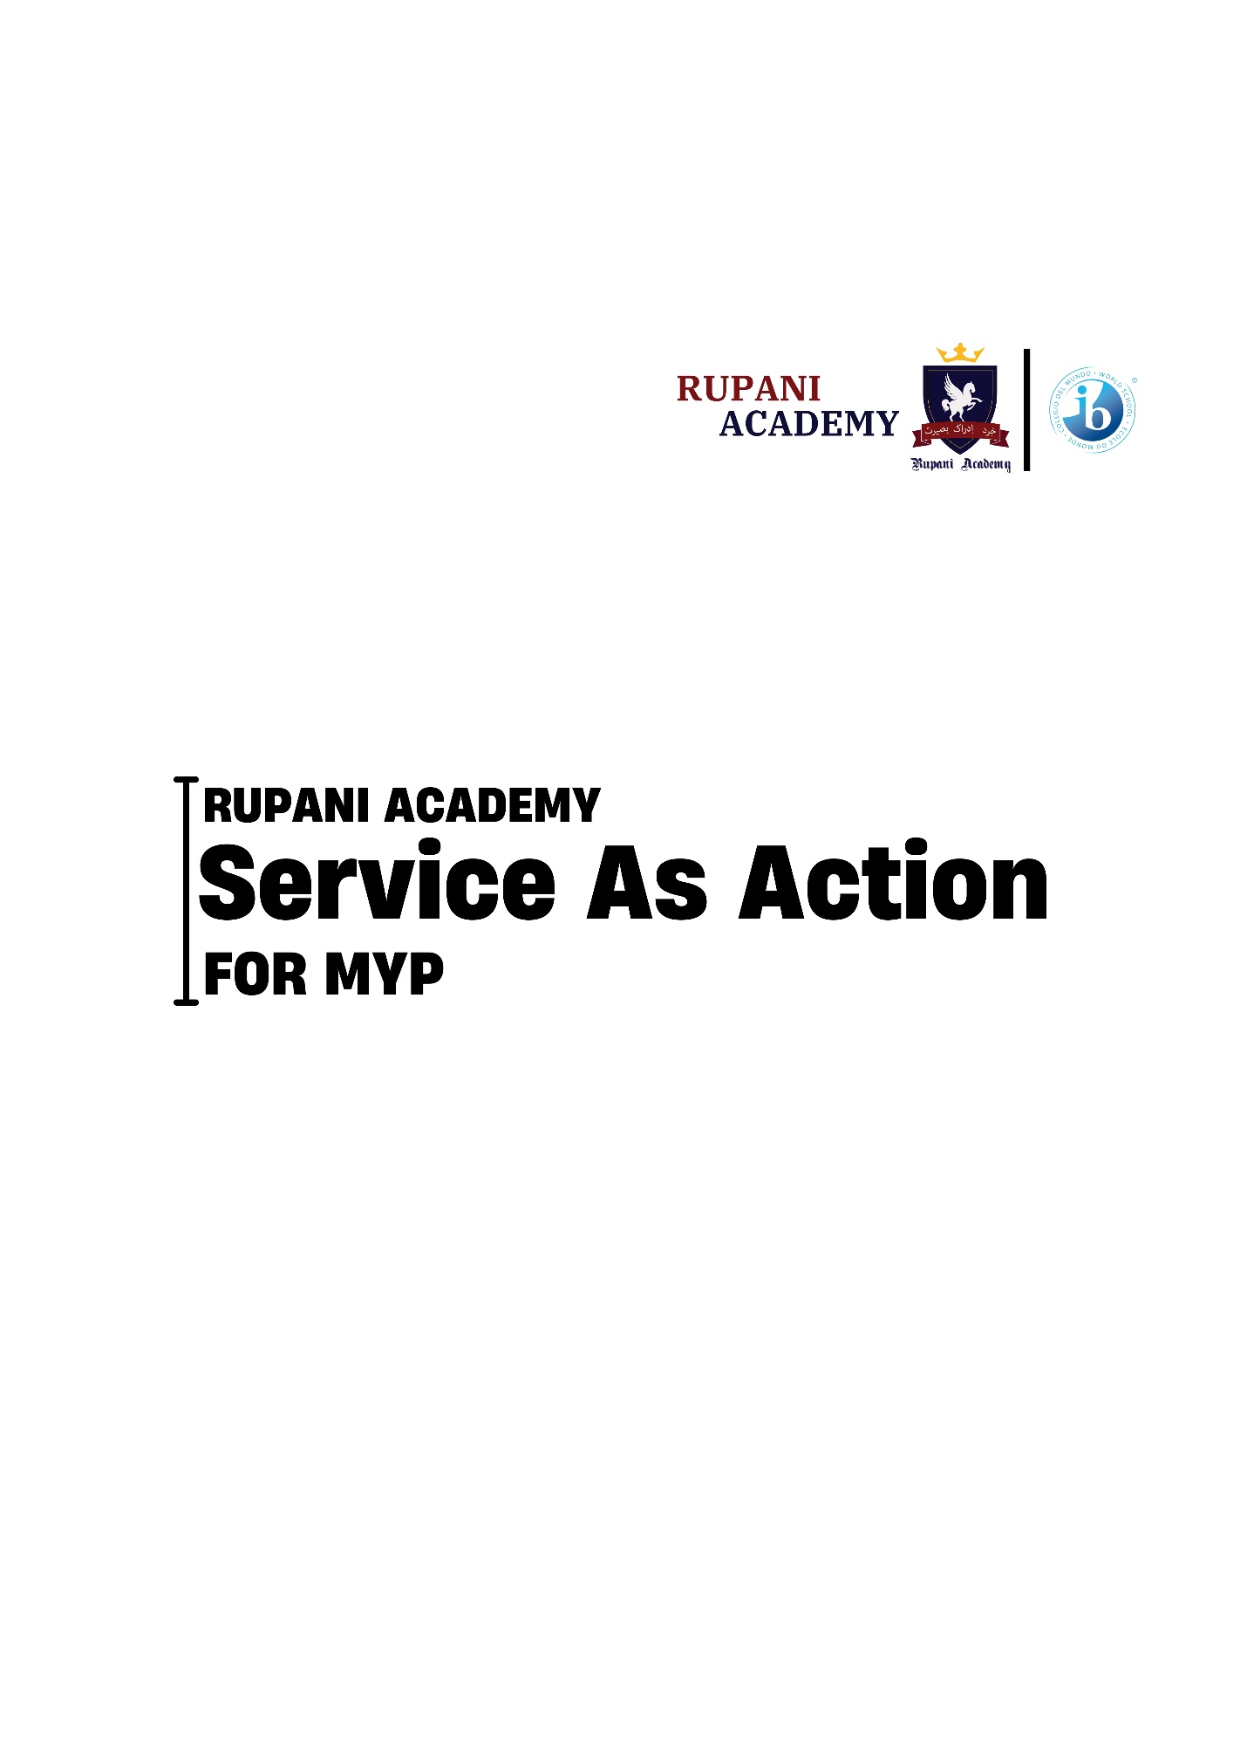

**CONTENTS**

1. Mission and Vision Statements.
2. IB Learner Profile.
3. Service as Action in IB.
4. MYP Learning outcomes for Service.
5. The five stages of Service learning.
6. Service as Action at Rupani Academy.
7. Service as action expectations map
8. Some Proposed Activities for SA
9. Proposal Form (Form-A)
10. Reflection Form (Form-B)

**IB Mission Statement**

The International Baccalaureate aims to develop inquiring, knowledgeable and caring young people who help to create a better and more peaceful world through intercultural understanding and respect.

**IB Vision Statement**

International Baccalaureate learners participate in an internationally accredited curriculum to become confident lifelong learners.

**Rupani Academy Mission Statement**

To provide quality education focusing on life skills and personality development for the upbringing of a generation of productive and contributing global citizens.

**Rupani Academy Vision Statement**

A sustainable, educated and pluralistic society for future generations.

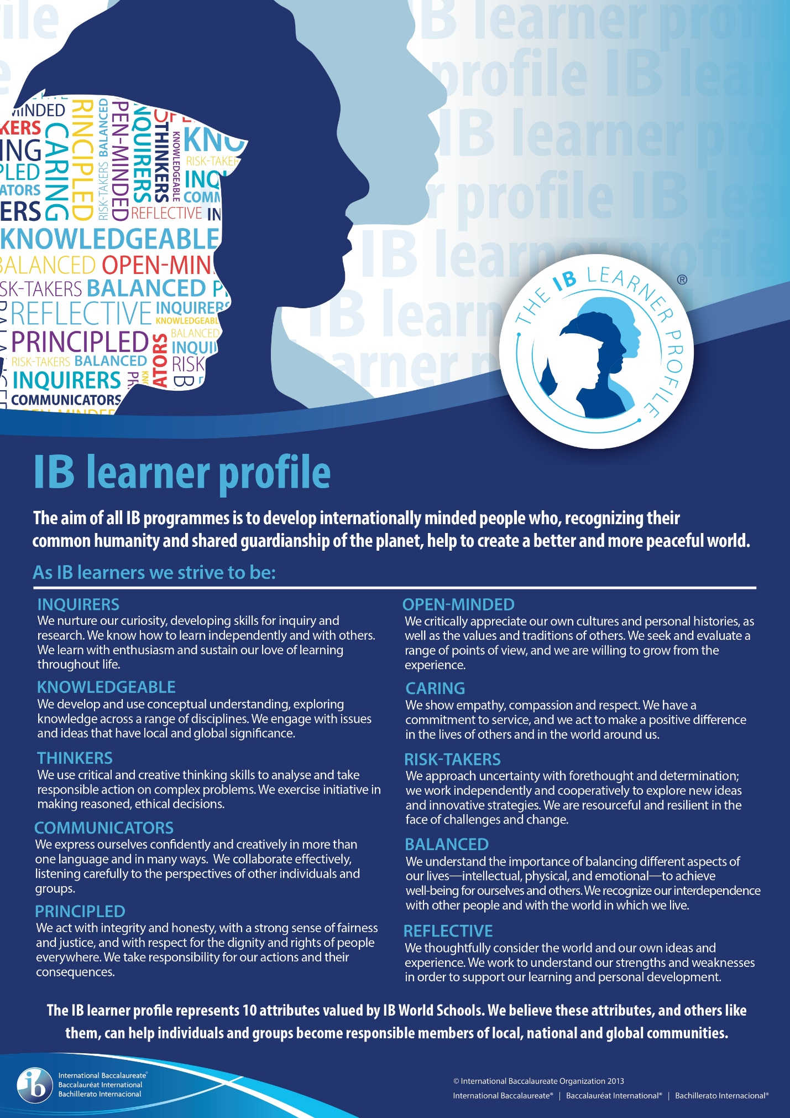

**Service as action in IB MYP**

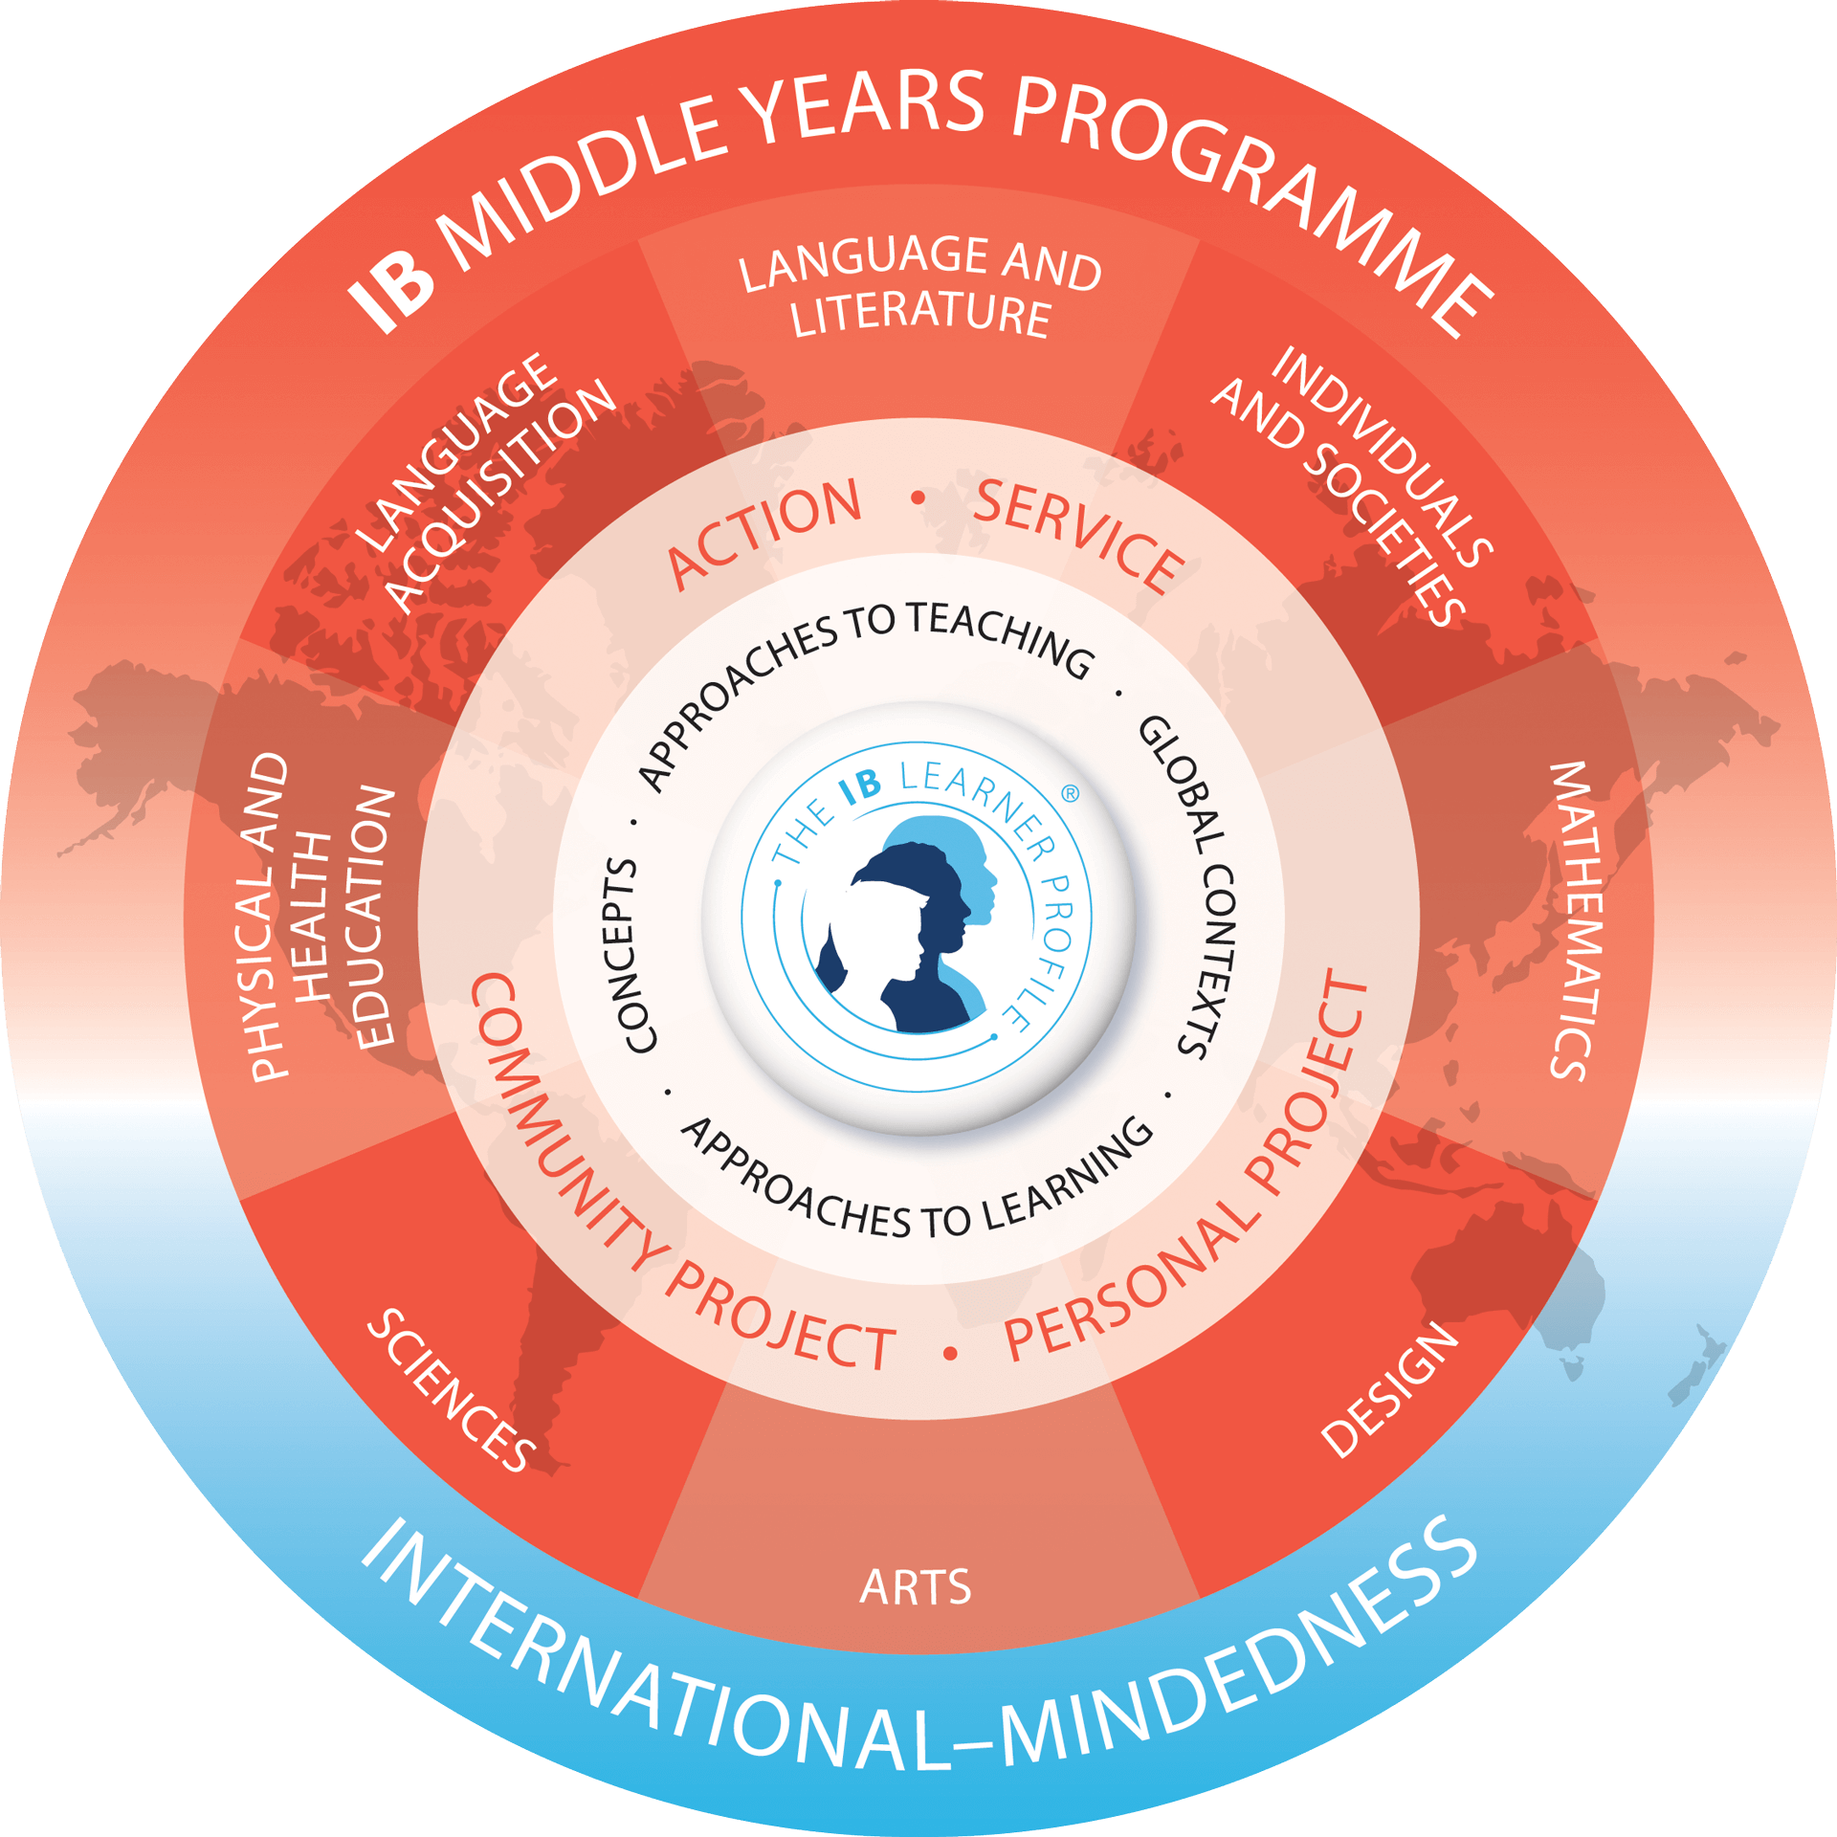

**Service** is learning by doing and experiencing, and is a key component in constructivist models of education, including the kind of teaching and learning common to all International Baccalaureate programmes. Through responsible action, tightly connected with sustained inquiry and critical reflection, young people and adults can develop the kinds of attributes described by the learner profile that are essential for success in future academic pursuits and life beyond the classroom.

**Action** as a subset or particular kind of action, has always been a shared value of the IB community. IB learners strive to be caring members of the community who demonstrate a personal commitment to service, and act to make a positive difference to the lives of others and to the environment.

**Service as action** with appropriate guidance and support, Middle Years Programme students should, through their engagement with service as one of the significant forms of action, meet the learning outcomes to develop the skills and attributes of an IB learner. IB World Schools value service with others as an important way to engage in principled action across a range of overlapping local and global communities.

• feeling empathy towards others.

• making small-scale changes to their behavior.

• undertaking larger and more significant projects.

• acting on their own.

• acting collaboratively.

• taking physical action.

• suggesting modifications to an existing system to the benefit of all involved.

• lobbying people in more influential positions to act.

MYP learning outcomes for service

• Become more aware of their own strengths and areas for growth

• Undertake challenges that develop new skills

• Discuss, evaluate and plan student-initiated activities

• Persevere in action

• Work collaboratively with others

• Develop international-mindedness through global engagement,

multilingualism and intercultural understanding

• Consider the ethical implications of their actions.

The five stages of service learning

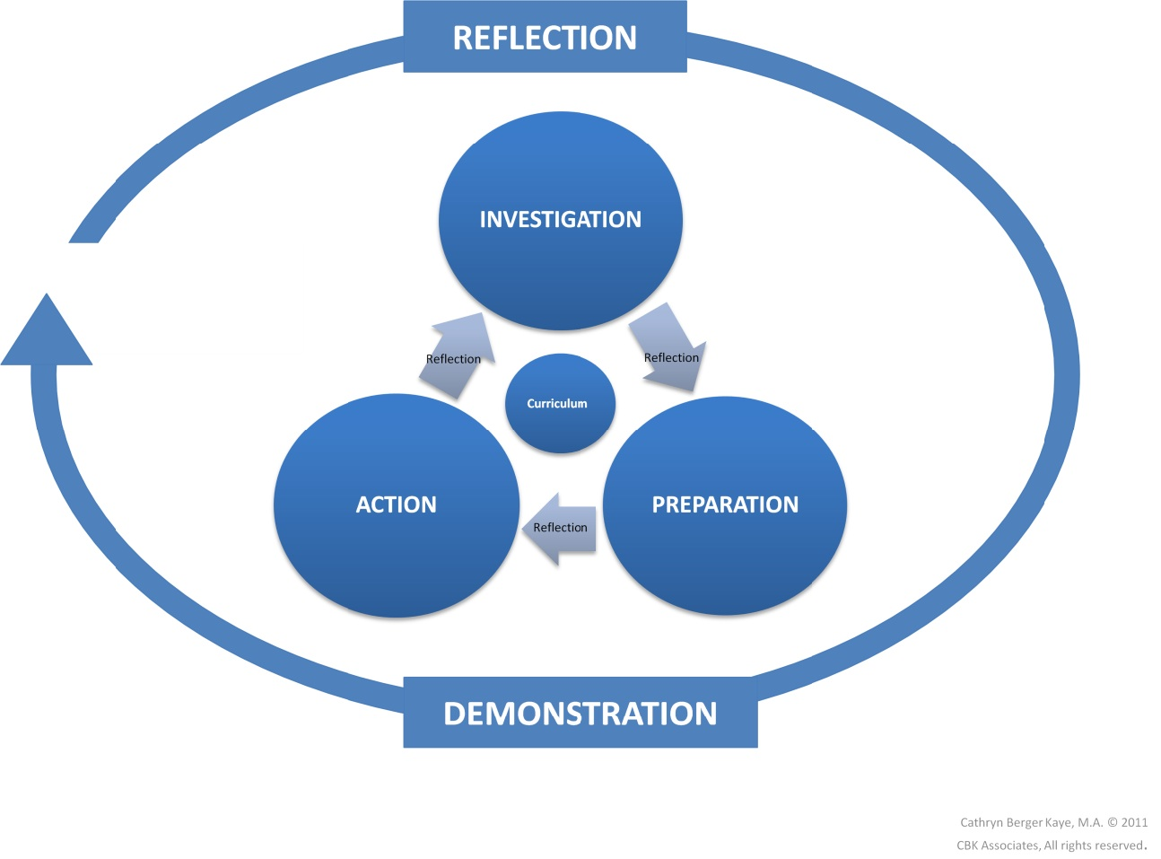

The five stages of service learning in the International Baccalaureate (IB) program are investigation, preparation, action, reflection, and demonstration. Students begin by researching community needs, then prepare and plan their service activities. They take action to address those needs, reflect on their experiences, and finally demonstrate their learning and impact. This cyclical process promotes meaningful engagement and personal growth.

Service as Action at Rupani Academy

Service as Action is an integral component of the International Baccalaureate's Middle Years Programme (MYP) at Rupani Academy, emphasizing the importance of contributing to the community and fostering a sense of social responsibility among students.

At Rupani Academy, Service as Action goes beyond mere volunteering; it is about students actively engaging with real-world issues, developing empathy, and taking meaningful steps to address them. Through service projects, students not only apply classroom learning in practical situations but also develop essential skills such as communication, collaboration, and critical thinking.

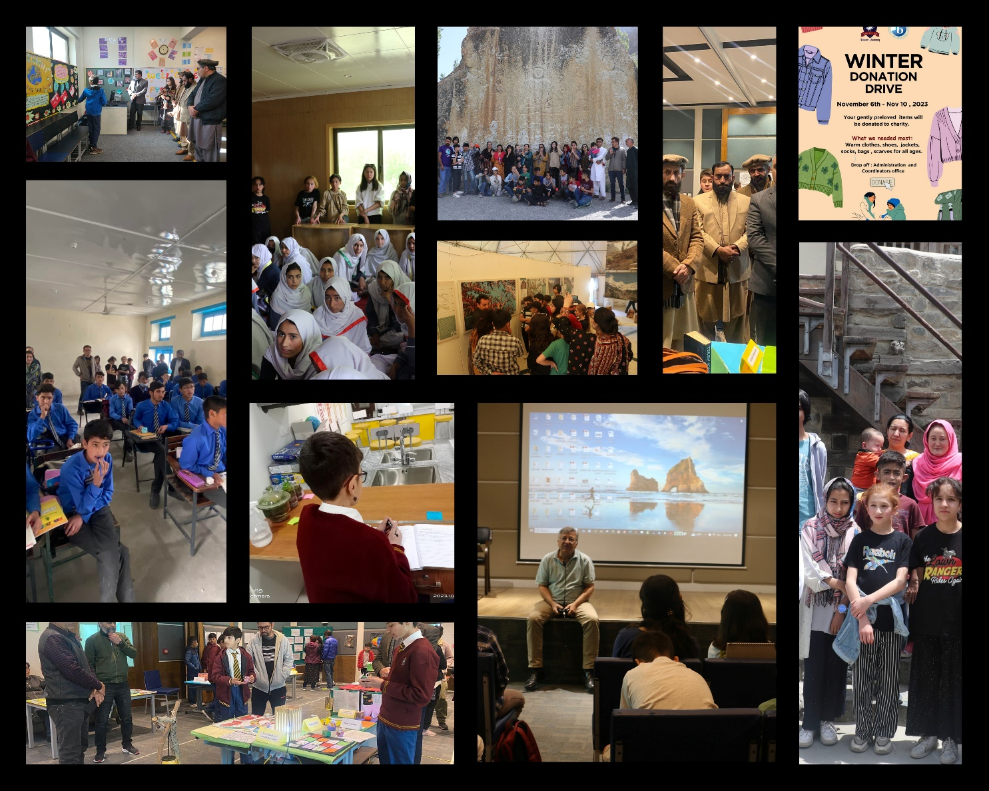

Some Glimpse of School.

The academy encourages students to identify areas of need within the local and global community, allowing them to choose service activities that align with their interests and passions. Whether it's environmental conservation, supporting marginalized communities, or promoting education, students are empowered to make a positive impact in areas they are passionate about.

Moreover, Service as Action at Rupani Academy is not confined to a one-time event but is integrated into the curriculum throughout the academic year. Teachers incorporate service-learning opportunities into unit plans, encouraging students to reflect on their experiences and understand the broader implications of their actions.

By participating in Service as Action initiatives, students at Rupani Academy not only fulfill the requirements of the MYP but also develop into socially responsible individuals equipped to make meaningful contributions to society. Through their service efforts, they embody the values of compassion, empathy, and active citizenship, ultimately shaping a brighter future for themselves and their communities.



SERVICE AS ACTION EXPECTATIONS MAP

|  |  |  |  |  |
| --- | --- | --- | --- | --- |
| **MYP 1**  **Emerging** | **MYP 2**  **Evolving** | **MYP 3**  **Evolving** | **MYP 4**  **Consolidating** | **MYP 5**  **Consolidating** |
| Local based service-school based activities | The Local Community | The Regional Community | The National / Global Community | Service can be linked to the Personal Project |
| **What can be done within school to make it better?** | **What can be done within school to help the wider community?** | **What problem(s) are in my community and how can I provide a solution?** | **What problem(s) are within the regional community, and can I find a solution?** | **What am I passionate about and how can I use it to identify a local, regional or global problem to support my PP?** |
| Individual/Whole group activities or guided activities.  Show an understanding of action and service, why we do it.  Show an understanding of acceptable events, and how to access communities in need.  Show an understanding of commitment and organization (e.g. punctuality; planning) | Increased planning responsibility by ensuring the event runs smoothly.  Student-led initiatives emerging.  Show awareness of need and learn to fulfill that need. Begin to align with ATL skills.  Proactively seek out events and make suggestions for activities.  Begin finding specific groups/organizations of interest developing awareness of longer-term commitments. | Responding to and reflecting on the needs of the Regional community.  Being more aware of what ATL skills are being developed and developing a sense of independent leadership.  Independently connect ideas to SA outcomes and activities.  Begin to develop independent evaluations and reflections. | Find a need within a National/Global community and choose an appropriate type of service to help that need.  Take charge of the event with planning, organization, implementation, configuration, problem solving, execution, facilitation, and follow up.  Confident evaluations and reflections | Students have found their  passion through their Personal  Project. They can choose  whether to extend their PP into  a SA or not.  What local, regional or global  communities are within the  project?  What needs do they have?  How can students link the  needs identified in their PP to  Action as Service? |
| **2 Short term Projects** | **2 Short term**  **Projects** | **2 Short term Projects** | **1 Short term Project** | **Service as Action linked with Personal Project** |
| **1 Long term Project** | | | **1 Long term Project** |
|  |  |  |  |  |

SERVICE AS ACTION EXPECTATIONS MAP

|  |  |
| --- | --- |
| **Required Evidence as Digital Folder**  • 2 descriptions of goals and learning outcomes  • 2 pieces of evidence of planning and involvement (e.g. planning notes, pictures, diary extracts)  • 2 reflections including selected learning outcomes | **Required Evidence as Digital Folder**  • 4 descriptions of goals and  learning outcomes  • 4 pieces of evidence of  planning and involvement  (e.g. planning notes,  pictures, diary extracts)  • 4 reflections including  selected learning outcomes |
| **Approaches to Learning (ATL) Skills Focused:**  • Self-management  • Thinking  • Social  • Communication  • Research | |

**Role of Service as Action Coordinator.**

• The Service as Action Coordinator will collaborate with teachers to develop SA possibilities in MYP units of work.

• Plan workshops in collaboration with Homeroom teachers helping students to understand the premises of Service as Action.

• Help communicate meaningful projects out to students and help support students in need.

• Work closely with Homeroom teachers to ensure monitoring and quality of the SA activities students are involved in and record evidence on digital folder.

Some Proposed Activities for SA

* Teach our house-keeping staff basic conversational English.
* Collect used toys/clothes from all grades and give it to Toy bank/ Orphanage.
* Create teaching aids for Classrooms.
* Creating a wall mural
* Organize a school-wide recycling initiative to promote environmental sustainability.
* Run a donation drive campaign to collect money for Orphanages.
* Partner with a nearby orphanage to organize a fun day for the children, including games, crafts, and snacks.
* Organize activities such as play, movies, dance, story tell etc for senior citizens.
* Giving coaching to unprivileged kids in the community.
* Books collection and donation to unprivileged students
* Conduct a fundraiser for a charity organization supporting education in underprivileged communities, such as providing school supplies or sponsoring a street child's education.
* Partner with a local animal shelter to assist with animal care tasks and promote pet adoption through awareness campaigns.
* Field trips to give awareness about local issues and problems.
* Connect with environmental departments to come up with ideas to overcome Global warming issues.
* Run a campaign to save street animals such as dogs, cats etc.
* Run a campaign to save wildlife animals (e.g. Partner with WWF)
* Develop and share blogs/vlogs to give awareness about climate change.
* Arrange news room/ podcast/ brushers to give awareness about mental health.
* Design and Arrange visits to kid’s/women central jail for activities.
* Arrange exhibitions to share their learnings with wider community.

**Note:**

* **Students are encouraged to come up with innovative ideas for SA.**
* **Teachers are encouraged to involve students and parents for SA. Teachers can come up with their own ideas related to the unit.**
* **No budget from school is allocated for Service as Action activities held within or outside the school.**

